2033. Minimum Operations to Make a Uni-Value Grid

Question : [ https://leetcode.com/problems/minimum-operations-to-make-a-uni-value-grid/submissions/1990038041/?envType=daily-question&envId=2026-04-28 ]

Solution :

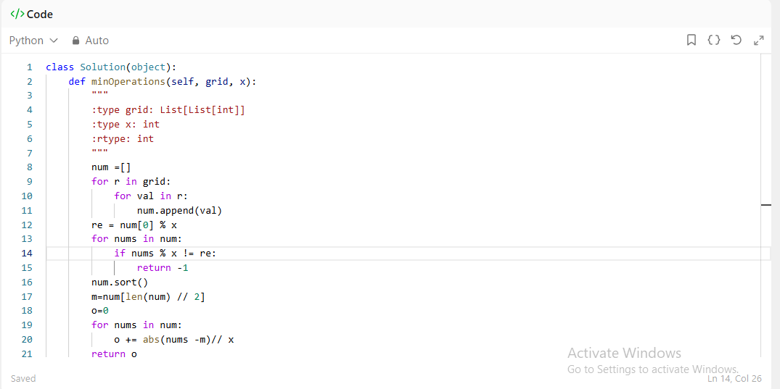

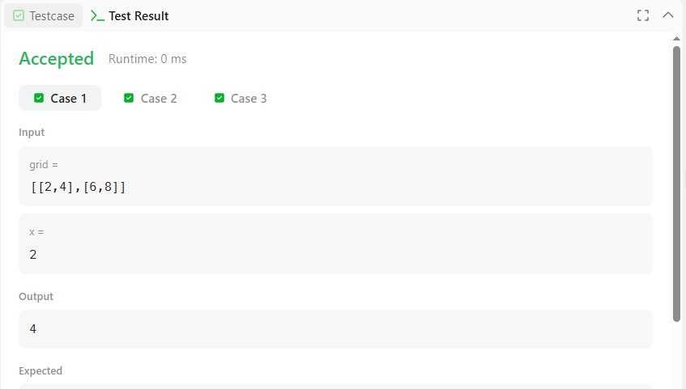





Complexity

Time: O(n log n)

Because we are here perform sorting

Space: O(n)

